附件二
网上集中采集使用手册
Centralized Photo Collection Manual
一、照片要求见下图，请严格按要求提供照片：
Please refer to the following picture for photo requirements. Please provide photos strictly according to the requirements:
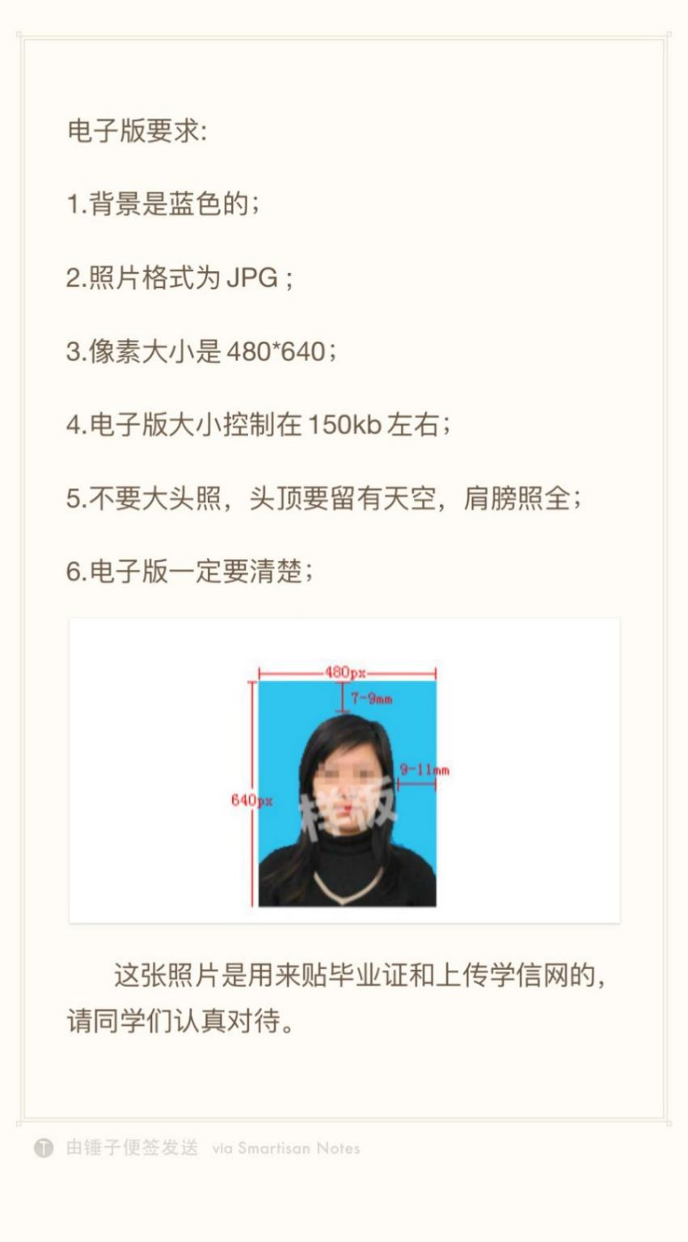
Electronic photo requirement:
1. Blue background;
2. JPG Photo format;
3. 480x640 Pixel size;
4. Electronic photo size should be around 150kb
5. Don't take a headshot, leave space above your head, and take a photo of both shoulders;
6. Electronic photo must be clear;

This photo will be attached to the graduation certificate and uploaded on the the China Higher Education Student Information and Career Center (CHESICC) website, please take it very seriously.

二、线上采集操作方法 | Online photo collection operation manual:
- 登录 | Login
- 使用浏览器访问地址 http://www.xinhuacu.com/www/#/login.
Use a browser to access the website http://www.xinhuacu.com/www/#/login.
- 登录账号：手机号+验证码进行注册登录。
Login your account: mobile phone number + verification code for registration and login.
注1：登录时必须勾选“提交代表同意”。
Note 1: You must select提交代表同意 (the area highlighted in red box below) when logging in.
注2： Chrome浏览器较稳定。
Note 2: Chrome is stable.
登录后显示以下界面：
After login, the interface below will be displayed:
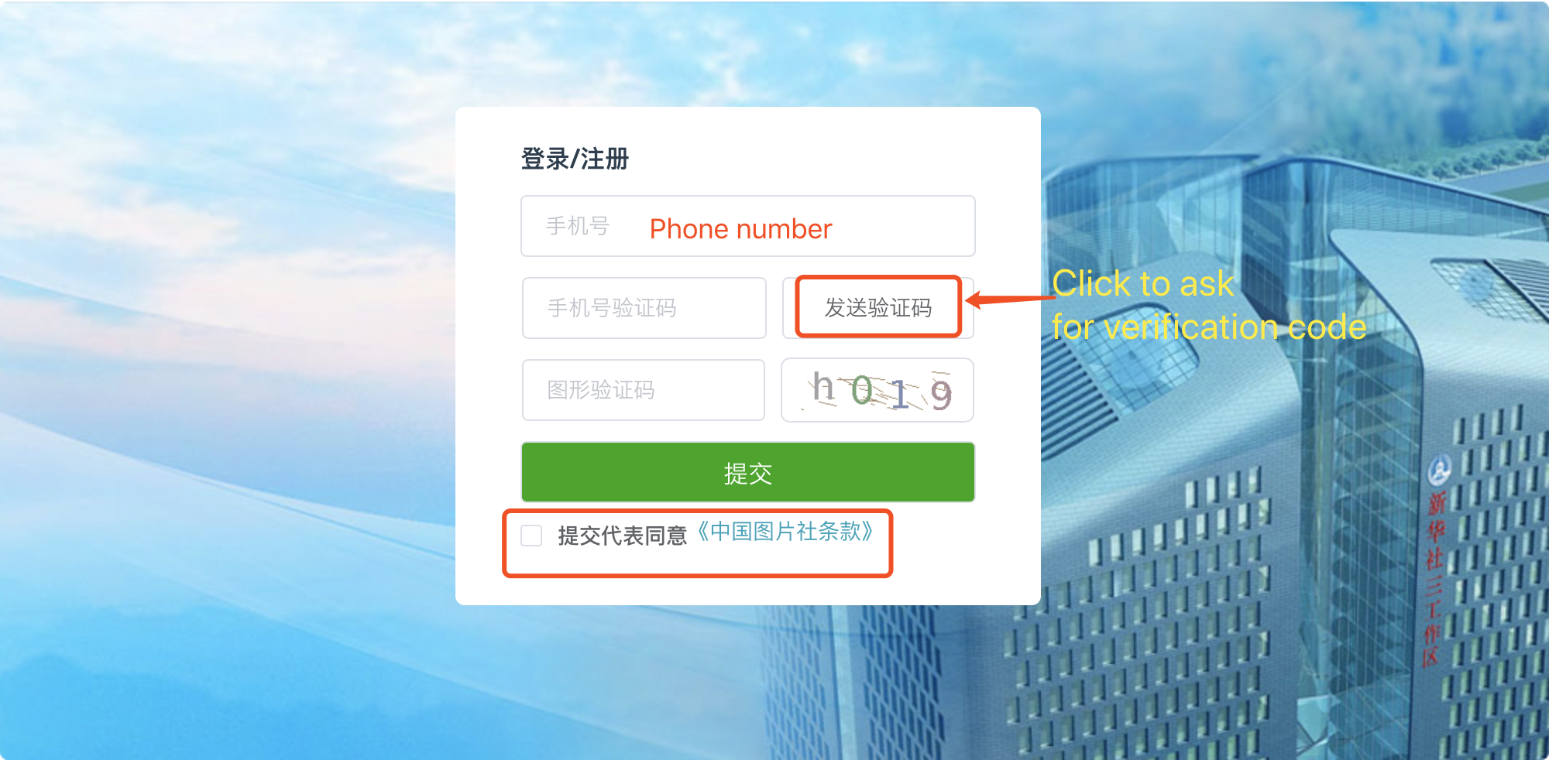
- 验证信息 | Verify information
（1）验证学校 | Verify the university
登录成功后，输入学校名称，点击提交。学校设置采集任务，页面跳转到验证学生信息页面。反之，提示您的学校未开放采集任务。
After successful login, enter the name of the school and click submit. The school sets the collection task and the page jumps to the student information verification page. If not, it will inform you that your university has not opened the collection task.
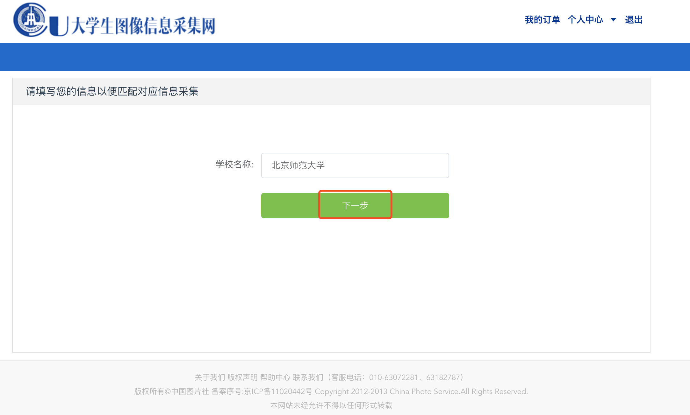
- 验证学生信息 | Verify student information
输入身份证号、学历层次，点击提交，有学生信息，跳转到提交照片页面；
Enter your ID number, academic level, and click submit. The page will jump to the page for submitting photos;
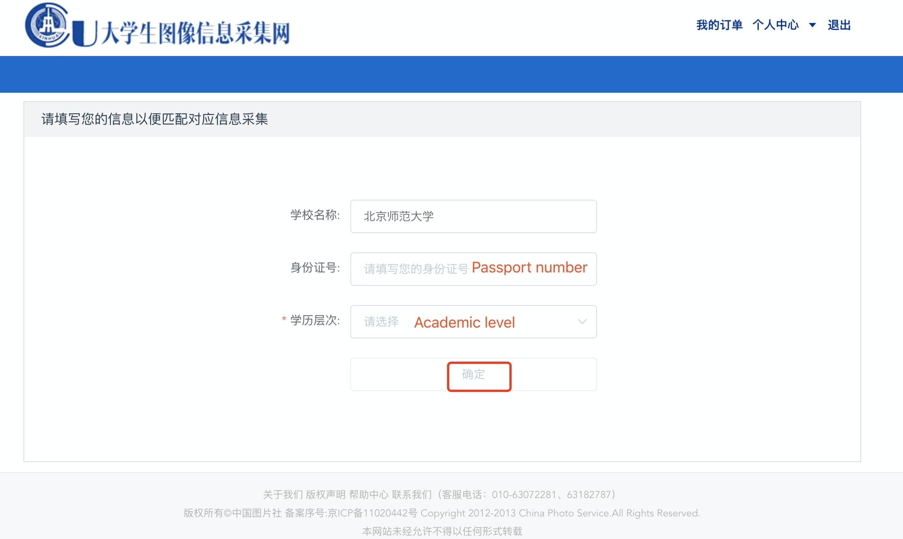

Academic level:
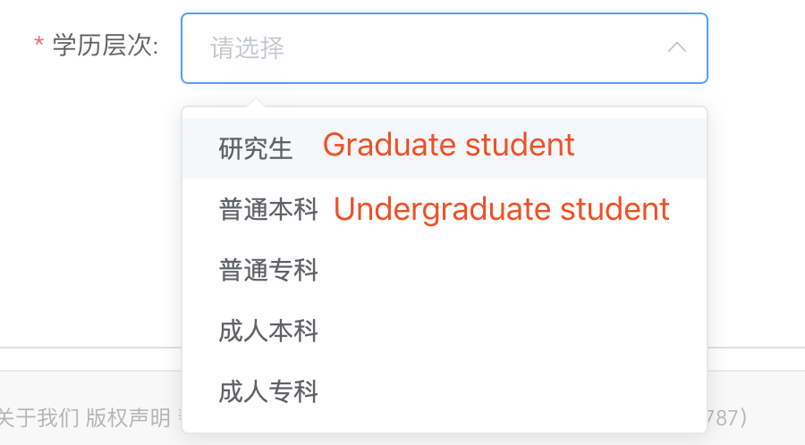

- 提交照片 | Submit photo
填写学生信息（注：护照号码请务必填写入学时的护照号码），上传图片，点击提交
Fill in student information（Please note that you must fill in the passport number when you enrolled in Beijing Normal University）, upload photo, and click submit.
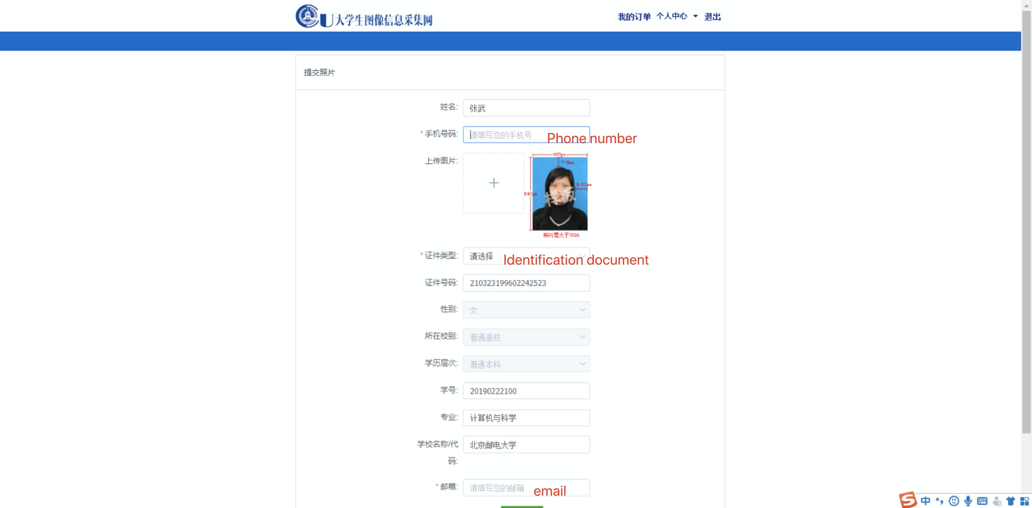
Identification document:
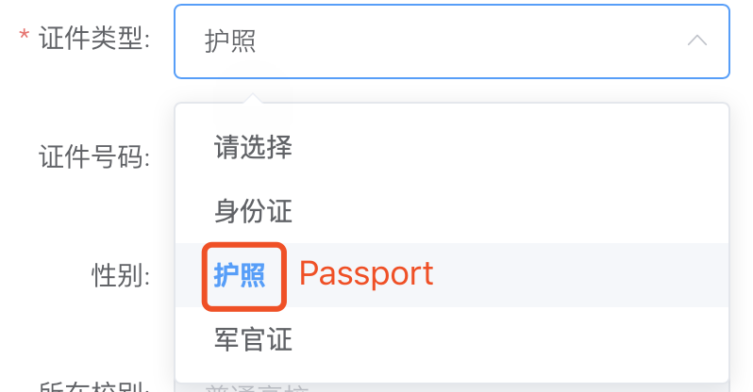
- 确认订单页面 | Confirm order
页面显示采集学生信息，点击修改，即可修改联系方式；点击支付，跳转到支付页面。
The page will show your student information. Click 修改to modify your contact information; click 确认支付 to access the payment page.
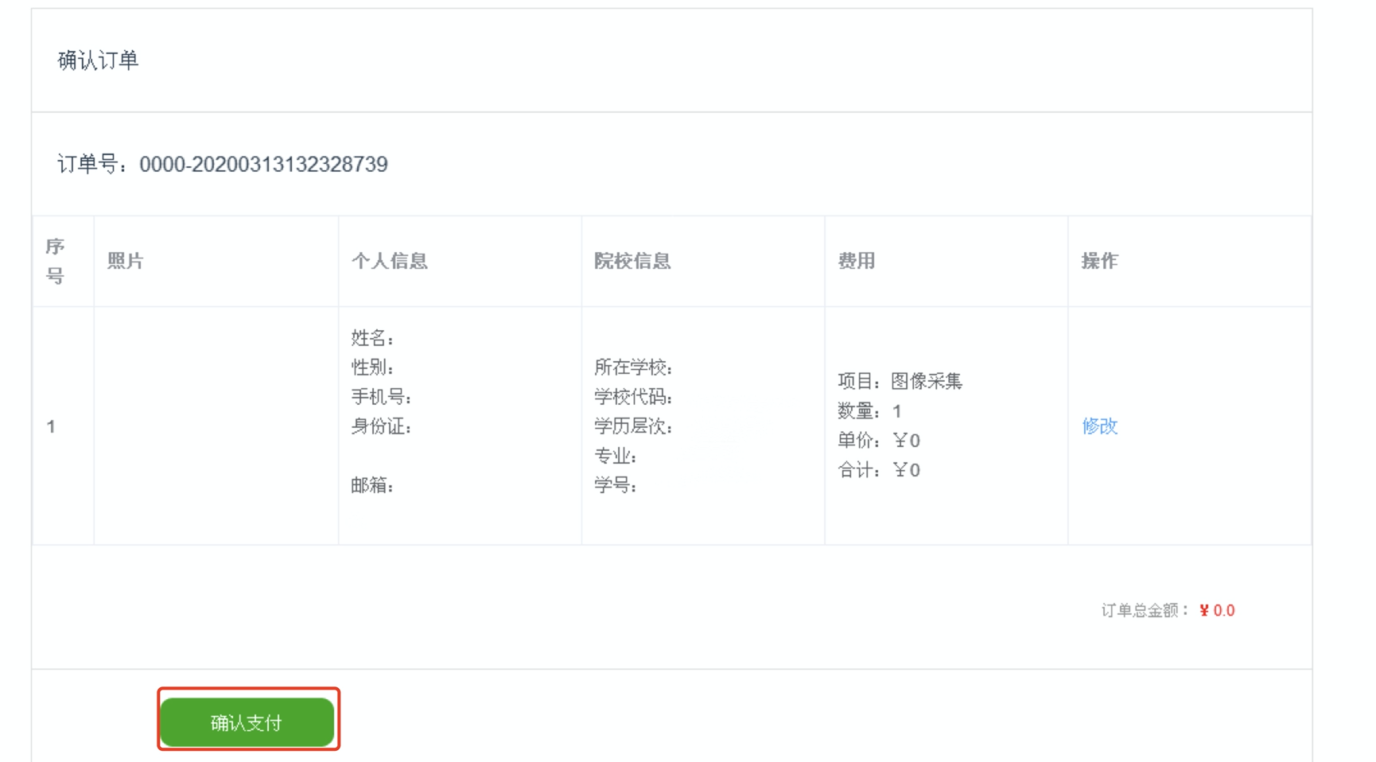
- 支付 | Make payment
选择支付方式（微信或支付宝），进行扫码支付，订单改变为已支付。
Select the payment method (WeChat or Alipay), scan code to pay. The order will change to “paid” after successful payment.
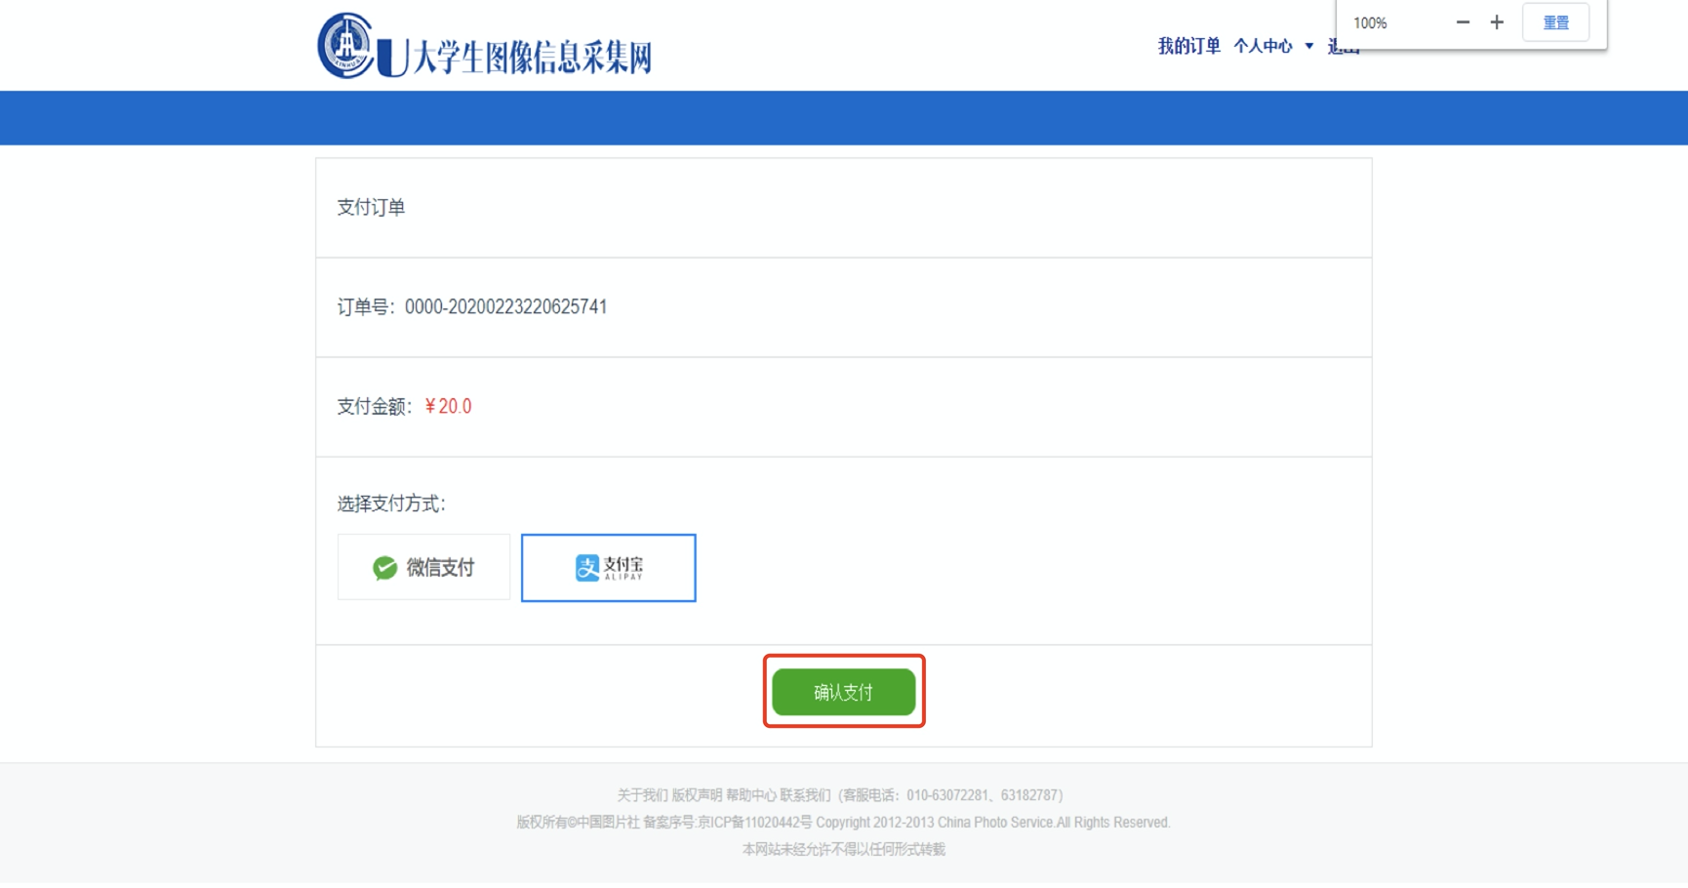
- 我的订单 | My order:
（1）已支付订单 | Paid orders
（2）未支付订单 | Unpaid orders
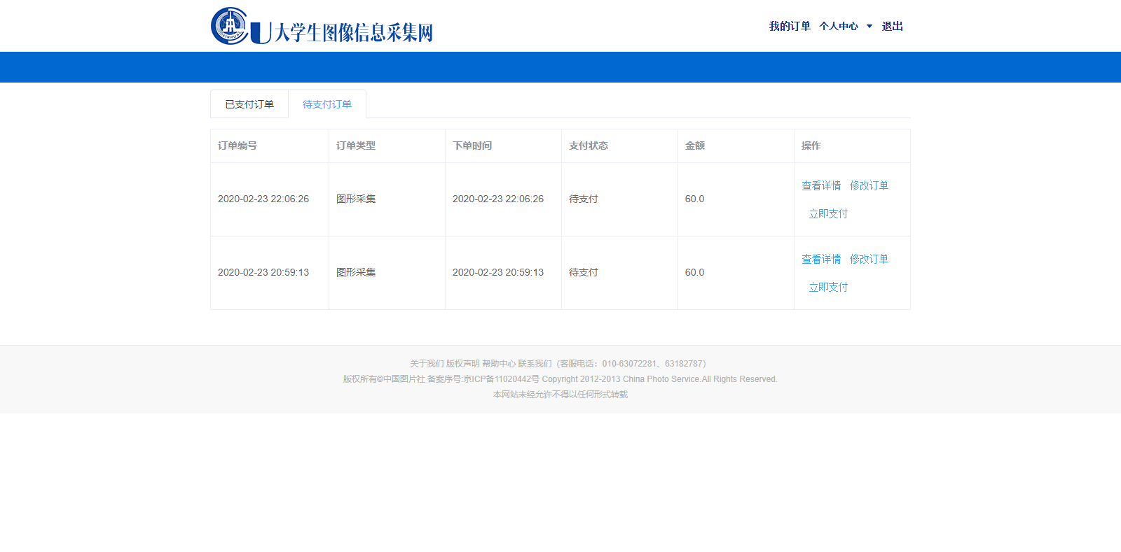
- 查看订单：显示订单详情（订单信息）。不可修改订单信息。
View order: display order details (order information). Order information cannot be modified.
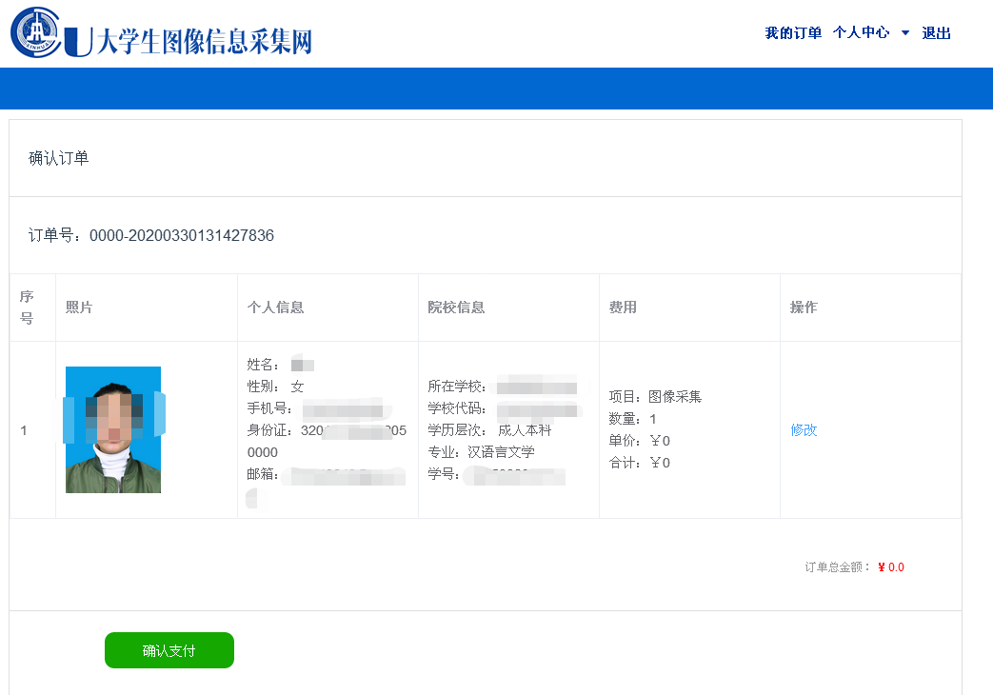
②修改订单：显示订单详情，可以修改订单信息。
Modify order: display order details, you can modify order information.
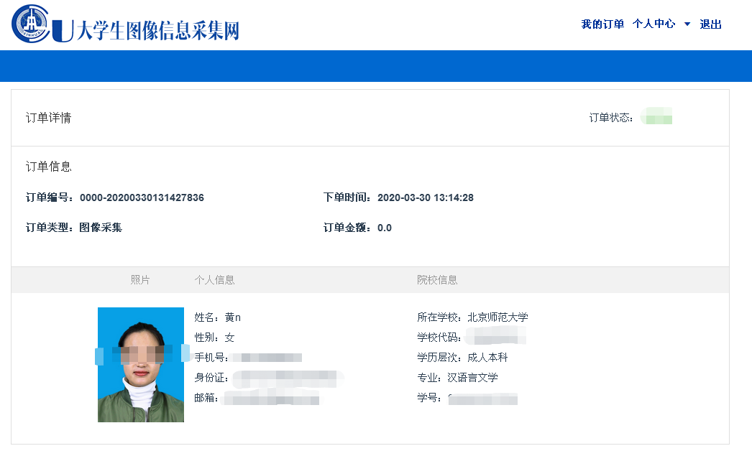
③支付订单，选择支付方式（微信或支付宝），进行支付。
Pay, select the payment method (WeChat or Alipay) and make the payment.
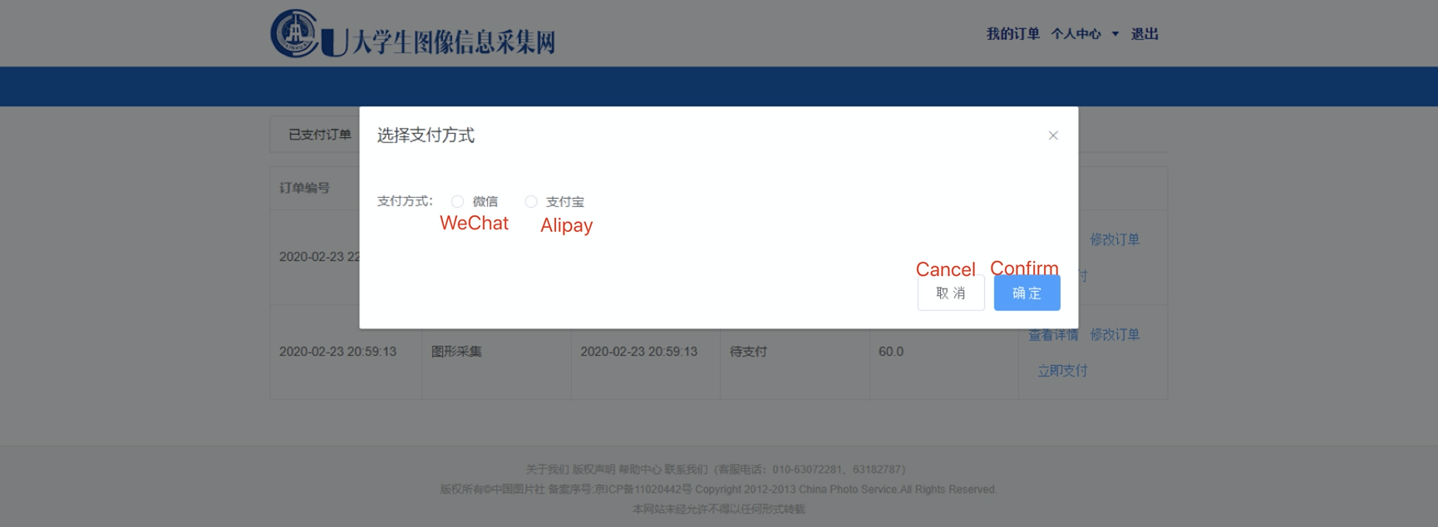
- 个人中心 | Personal information Center
（1）个人中心，显示个人信息，点击修改，保存即可修改订单信息。
Personal information center, display personal information, click modify, save to modify order information.
（2）修改手机号：输入原手机号，新手机号，获取验证码，输入新手机号验证码，点击保存，即修改账号。
Modify the mobile phone number: Enter the original mobile phone number, enter the new mobile phone number, get the verification code, enter the new mobile phone number verification code, click Save, and then modify the account.

- 退出登录 | Log out
点击右上角，退出登录，跳转到登录页面。
Click the upper right corner to log out and return to the login page.


